**Recommend complete by 19 April**

# Details of Required Network Design

## Diagram:

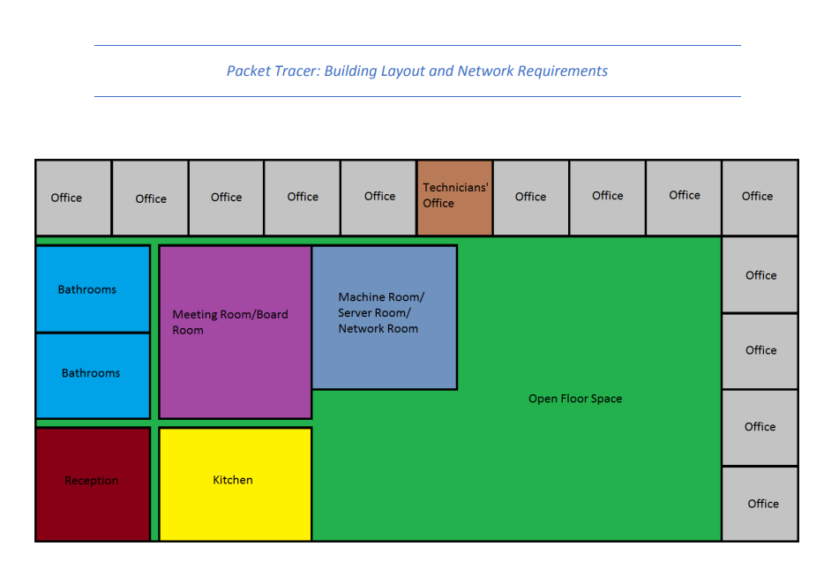

### Building:

* Singel-story detached property.
* 100 x 50 meters in size (5000m^2)
* Ample space in ceiling
* A lot of natural light

Each staff member should be able to connect 1 to 4 devices to the network. Devices should be treated as untrustworthy. May estimate the number of employees based on other network requirements.

All networked devices should be able to connect to the Internet. Each device connects using a wired access point capable of 50 Mb/s synchronously, and each device that connects via Wi-fi should be capable of 10 Mb/s synchronously. ASSUME EXTANT OF FIBRE ISP SETUP CAN HANDLE THE SPEEDS REQUIRED; TASKS IS TO DESIGN THE NETWORK INSIDE BUILDING.

### Sections:

#### Offices:

* 13 Offices
* 2 to 4 people per office (Desktops or laptops with Ethernet ports)
* 4 wired access points providing network access.
* Wi-Fi available for 2 to 4 devices per person
* OFFICE IN UPPER LEFT CORNER IS USED AS STORAGE SPACE, DOESN’T NEED NETWORK ACCESS (indicated with yellow circle)

#### Technician’s Office:

* 2 Technicians (laptops or desktops with Ethernet ports)
* 2 wired access points for office work
* 4 wired access points for potential office equipment maintenance
* Direct wired access to machine room
* Wi-Fi available for up to 8 devices per technician

#### Reception/ Waiting Area:

* 2 People (laptops or desktops with Ethernet ports)
* 2 Wired access points – one per person
* Full Wi-Fi available for reception staff; 2 to 4 devices per person
* 1 Networked printer available
* Limited Wi-Fi for guests

#### Kitchen:

* 4 wired access points for IoT devices
* Wi-Fi for staff

#### Meeting room/ board room:

* 20 to 30 people
* Set up for teleconferencing.
* 2 Wired access points for hardware used for teleconferencing.
* Wi-Fi for staff

#### Machine room/ Server room:

* No staff, except technicians
* The room has independent ventilation and is sound proofed.
* Company policy:
  + All servers, routers and major switches must be located inside this room.
  + Only switches with less than 8 ports may be used outside the machine room.
  + The company owns servers that live in this room.
  + Servers are used for:
    - centralized data and file storage
    - projects with server infrastructure requirements,
    - work-from-home support.
    - intranet hosting
  + Servers are capable of providing network services (DHCP, NAT, DNS)
  + YOU CAN SELECT ANY SERVER(S) IN POCKET TRACER THAT YOU DEEM APPROPRIATE, JUST DON’T GO OVERVOARD (won’t add to budget)
* Servers primarily accessed remotely from technicians’ office.
* No wired access points apart from open ports on network hardware
* The ISP fiber line terminates here, so all Internet traffic flows through this room, but not necessarily through the servers.
* No Wi-Fi needed.

#### Open Floor Space:

* Multi-functional office space can be adapted to best suit current tasks and projects.
* Space for 75 to 100 people
* Floor raised to allow cabling to run under the desks to machine room.
* 100 wired access points for Ethernet-capable devices
* Wi-Fi for staff
* 5 Networked printers available next to the machine room.